*Case Study 2*

1. Requirement Definition (RD)

-Admin can register the staff through the system by entering individual’s username and password.

-Admin can check log in detail.

-Admin can view, remove and update report information.

-Delivery-staff can log in with their name and password to access the system.

-Delivery-staff can view the customer and delivered items information.

-Delivery-staff can report the delivery list to admin via the system.

1. Data Requirements

-Delivery –staff details

-Log in information

-Location history

-Delivery fees

-Cash details

-Daily Report

1. Functional Requirements

-The system can support delivery staff information.

-The system can set delivery fees on locations.

-The system can calculate cash, daily profit, staff salary and income.

-The system can access delivery reports by dates.

1. Non-functional Requirements

-The system can save daily reports into the database safely.(ACID properties)

-The system can create a backup database file after every transaction (fees, income, profit, salary, update of authentication details).

- The system can support all the PC (Personal Computer), mobile phones , tablets.

- For security issues only admin can change the password on behalf of staffs.

- Staffs can only access this system for seeing location, fees, salary and updating daily report.

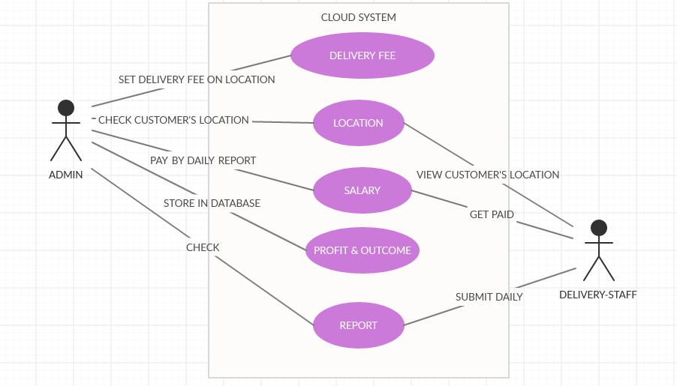

Fig . Use Case Diagram for Delivery Management System